**PHYS 101 - Measurement and Uncertainty in Scientific Experiments**

32/34

**Worksheet**

*Complete the worksheet as a group and turn in a single document with your names.*

Colin Beckett _____________________

_____________________ _____________________

*Show all work and calculations to receive full credit! You may use additional sheets.*

1. Significant Figures
   1. Suppose you are measuring the mass of a pendulum bob on an electronic mass balance. The mass balance reads “10.4 g”. How many significant figures does this reading have?

2/2

3 significant figures

* 1. What is the relative uncertainty of this measurement, expressed as a percent error? (Recall that the precision of an electronic instrument is usually equal to the smallest difference it can detect 0.1 g in this case)

1.5/3; *relative* uncertainty is a fraction: .1g/10.4 g.

Relative uncertainty = .1 g.

Relative uncertainty expressed as a percent error: .1g/1 x 100% = 10%

* 1. Suppose you measure the mass with a more precise electronic mass balance, that can measure mass with a precision of 0.01 g. If the mass balance reads “10.40 g”, how many significant digits are there? Write this value so that the number of significant digits is not ambiguous.

3/3; don’t forget units

There are 4 significant figures. 10.40 = 1.040 x 10^1

1. Propagation of Uncertainty

You are asked to measure the volume of a spherical object. Knowing that the volume, V, is related to the radius, R, by , you measure the radius to be 2.2 cm ± 0.1 cm.

* 1. Convert the measurement of the radius to meters and express the radius in scientific notation.

2/2; but in scientific notation, you should write so that only one power of 10: (2.2±0.1)*10^-2 m

R = 0.022 m ± 0.001 m

R= 2.2 x 10^-2 m ± 1 x 10^-3 m

* 1. Calculate the volume of the sphere (in cubic meters) using the measured radius and determine the **maximum relative uncertainty**.

V = (4/3)πr^3

ΔV = dv/dr Δr dv/dr = (4/3)π d/dr r^3 = (4/3)π3r^2 = 4πr^2  
ΔV = 4πr^2 Δr  
Δr = ± 0.001 m

4.5/5; good work, but wrong answer. Looks like you did 4/3pi*r^2 instead of r^3 in max uncertainty calculation

V= (4/3)π(0.022 m)^3

V= 4.5 x 10^-5 m

Maximum relative uncertainty = ΔV/V = (4πr^2 Δr) /((4/3)πr^2) = 3 x Δr = 3 x .001 = .003 = 0.3%

* 1. You now calculate the volume of a cylindrical object. The height is measured to be 5.2 cm ± 0.05 cm and the radius is measured to be 2.5 cm ± 0.05 cm. Calculate the volume and the **maximum relative uncertainty** of the volume calculation.

H = 5.2 cm ± 0.05 cm

ΔH = 0.05 cm

R = 2.5 cm ± 0.05 cm

5/5

ΔR = 0.05 cm

V = πr^2 x h

ΔV = dv/dr Δr + dv/dh Δh

ΔV = (2πrh x Δr) + (πr^2 x Δh)

V = π(2.5 cm)^2 x (5.2 cm)

V= 1.02 x 10^2 cm

Maximum relative uncertainty = ΔV/V = ((2πrh x Δr) + (πr^2 x Δh))/ (πr^2 x h)

= ((2π2.5(5.2) x .05) + (π2.5^2 x .05))/(π2.5^2 x 5.2) = 0.05 = 5%

14/14

1. Statistical Errors

*Watch “Video 4 – Ramp Experiment” before doing these exercises*

Your use a compressed spring to launch a wheeled cart up an inclined ramp (see video). We wish to know how far the cart is launched up the ramp, and this displacement can be measured using the ramp’s built-in ruler. The starting position of the cart is measured, and the displacement is then the difference between the starting and ending positions. To determine the precision of this measurement, you repeat and record your measurements 10 times.

Use the data to report an **average value** of the displacement and calculate the **standard deviation** and **standard error** in this value. Convert your standard error to a **percent error.** If you use Excel or some other program to automate these calculations, please include the Excel file or a screenshot of your work.

DATA:

|  |  |  |
| --- | --- | --- |
| Trial | End position (cm) | Displacement (cm) |
| 1 | 44.1 | 10.9 |
| 2 | 44.5 | 11.3 |
| 3 | 44.4 | 11.2 |
| 4 | 44.9 | 11.7 |
| 5 | 43.8 | 10.6 |
| 6 | 44.2 | 11.0 |
| 7 | 46.9 | 13.7 |
| 8 | 44.1 | 10.9 |
| 9 | 44.8 | 11.6 |
| 10 | 44.4 | 11.2 |

Average Value =

Standard Deviation =

Standard Error =

Percent Error =

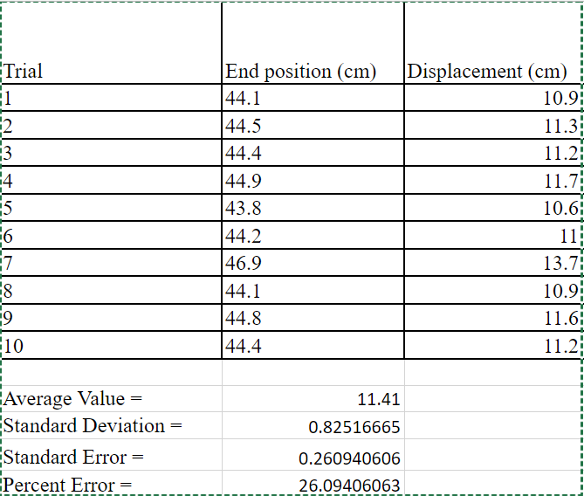

* 1. Comment on the “spread” of the data and what it says about the precision of your measurements.

The spread of data is not very precise. However, it is very accurate. This means that the data is close to the average, but not close to each other. The standard deviation shows accuracy. The standard deviation is small, so it is accurate. The percent and standard error show the precision. The percent and standard error are high, so it is not precise.

* 1. Identify specific sources of uncertainty in this experiment. Then, suggest some ways to reduce uncertainty and improve precision.

**Some sources of uncertainty are:**

The friction between the wheels and the track. (Does it have the same friction every time or do the wheels brush up against the side of the track)

The springs push on the cart

**Some ways to reduce uncertainty and improve precision are:**

make the friction between the wheels and the track as small as possible

make the spring stronger so it has the same force longer, does not get weaker or inconsistent